Budget

Database

Source: Oracle9i Developer: Developing Web Applications with Forms Builder
Palinski, J
ISBN: 0-619-15911-1
Course Technology
2004

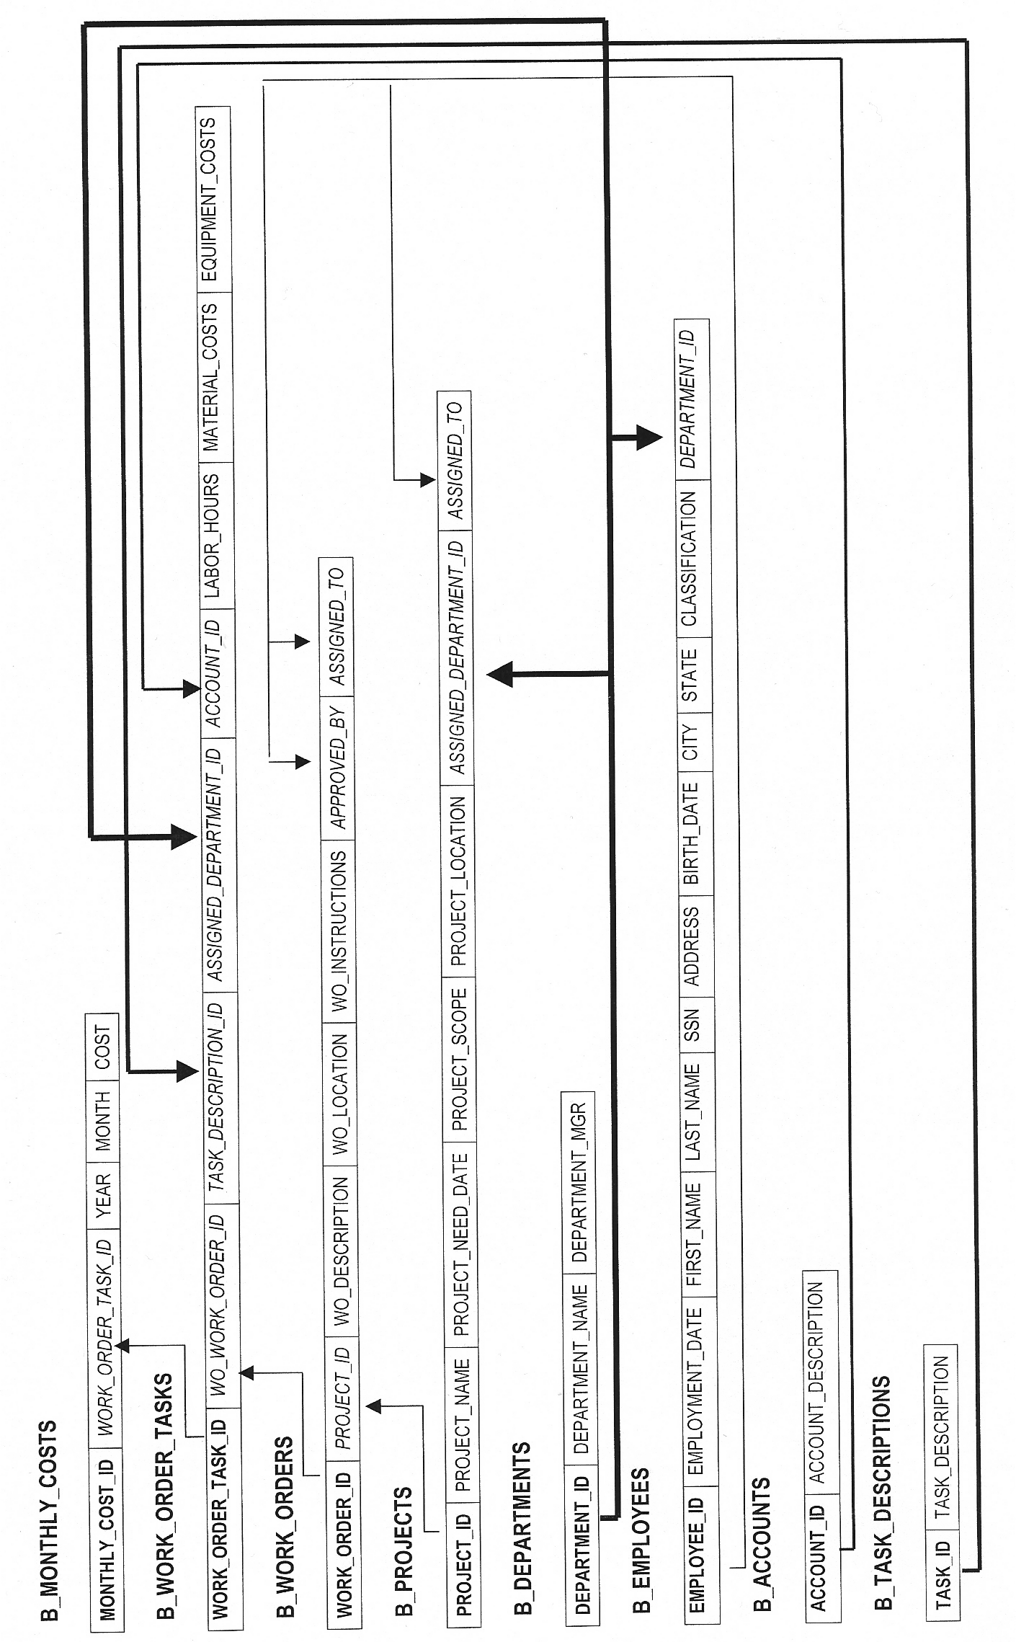

B_MONTHLY_COSTS

Name Null? Type
------------------------------- -------- ----
MONTHLY_COST_ID NOT NULL NUMBER(5)
WORK_ORDER_TASK_ID NUMBER(5)
YEAR NOT NULL CHAR(4)
MONTH NOT NULL VARCHAR2(9)
COST NOT NULL NUMBER(7)

MONTHLY_COST_ID WORK_ORDER_TASK_ID YEAR MONTH COST
--------------- ------------------ ---- --------- ---------
1 1 2003 JANUARY 5589
2 2 2003 JANUARY 5004
3 3 2003 JANUARY 4000
4 4 2003 FEBRUARY 2700
5 4 2003 MARCH 1370
6 5 2003 FEBRUARY 3000
7 5 2003 MARCH 1230
8 6 2003 APRIL 2000
9 6 2003 MAY 2000
10 6 2003 JUNE 3500
11 7 2003 APRIL 500
12 7 2003 APRIL 500
13 8 2003 JANUARY 25000
14 8 2003 APRIL 25000
15 8 2003 AUGUST 20000
16 9 2003 AUGUST 20000
17 9 2003 OCTOBER 20000
18 9 2003 DECEMBER 25000
20 10 2003 SEPTEMBER 400
21 10 2003 OCTOBER 1000
22 10 2003 NOVEMBER 1000
23 10 2003 DECEMBER 1000
24 11 2004 DECEMBER 1000
25 11 2004 JANUARY 2300
26 11 2004 FEBRUARY 1000

25 rows selected.

B_WORK_ORDER_TASKS

Name Null? Type
------------------------------- -------- ----
WORK_ORDER_TASK_ID NOT NULL NUMBER(5)
WO_WORK_ORDER_ID NOT NULL NUMBER(5)
TASK_DESCRIPTION_ID NOT NULL VARCHAR2(5)
ASSIGNED_DEPARTMENT_ID NOT NULL CHAR(2)
ACCOUNT_ID NOT NULL NUMBER(5,2)
LABOR_HOURS NUMBER(5)
MATERIAL_COSTS NUMBER(7)
EQUIPMENT_COSTS NUMBER(7)

WORK WO_WORK_ORDER_ID TASK_ AS ACCOUNT_ID LABOR_HOURS MATERIAL_COSTS EQUIPMENT_COSTS
---- ---------------- ----- -- ---------- ----------- -------------- ----------------
1 30001 GR SC 362.01 100 2589 3000
2 30001 CE SC 362.01 250 5000 4
3 30001 CP SC 362.01 160 4000 0
4 30006 CE SC 362.15 200 3700 370
5 30006 CP SC 362.15 250 4000 230
6 30007 CE SC 362.07 1280 7000 500
7 30007 CP SC 362.07 300 1000 0
8 30002 TE TC 370.01 0 70000 0
9 30009 TE TC 370.01 0 65000 0
10 30003 DE DC 583.01 600 2900 500
11 30004 DE DC 583.01 700 3500 800

11 rows selected.

B_WORK_ORDERS

Name Null? Type
------------------------------- -------- ----
WORK_ORDER_ID NOT NULL NUMBER(5)
PROJECT_ID VARCHAR2(10)
WO_DESCRIPTION NOT NULL VARCHAR2(100)
WO_LOCATION VARCHAR2(50)
WO_INSTRUCTIONS VARCHAR2(200)
APPROVED_BY NUMBER(5)
ASSIGNED_TO NUMBER(5)

WORK_ORDER_ID PROJECT_ID WO_DESCRIPTION WO_LOCATION ------------- ---------- ------------------------------------------------------------------------------------ ------------------------WO_INSTRUCTIONS APPROVED_BY ASSIGNED_TO -------------------------------------------------------------------------------------------------------- ----------- -----------------
30001 S1000000 Sub 3467 - Grade Foundation 320th West Center Rd Grade 1 acre lot per grading plan 1 10

30006 S1000000 Sub 3467 - Construct Building 320th West Center Rd Construct 50 by 20 building 1 13

30007 S1000000 Sub 3467 - Construct Equipment Foundations 320th West Center Rd Construct 3 transformer foundations per Drawing E-456 and 3 circuit break foundations per Drawing E-987 1 13

30008 S1000000 Sub 3467 - Install Transformer and Circuit Breakers 320th West Center Rd Install transformers C-12345, D-0965, and X-9809. Install Circuit breakers C9809, C0984, and CV9098. 1 10

30002 T1000001 Construct 15 miles of 345 kv transmission line from North Bend to Fremont North Bend Construct 15 miles of line using construction standard T-786 3 8

30009 T1000001 Construct 20 miles of 345 kv transmission line from Fremont to Elkhorn Fremont Construct 20 miles of line using construction standard T-787 3 11

30010 T1000001 Construct 15 miles of 345 kv transmission line from Fremont to Sub 3467 Sub 3467 Construct 15 miles of line using construction standard T-788 3 11

30003 D1000002 Construct electrical backbone for lots 1 - 50 in the Turtle Creek Subdivision 14509 S. 102nd St Install services per Distribution standard D-345 5 7

30004 D1000003 Construct electrical backbone for lots 68 - 102 in the Gorzelanski Acres Subdivision 4590 S. 13th St Install underground services per Distribution standard D-348 5 12

30005 D1000004 Replace transformer 3PM8790 with 3PM98034 at Lozier Foods 13678 Dodge street Replace transformer per Drawing C-98 5 7

10 rows selected.

B_PROJECTS

Name Null? Type
------------------------------- -------- ----
PROJECT_ID NOT NULL VARCHAR2(10)
PROJECT_NAME NOT NULL VARCHAR2(60)
PROJECT_NEED_DATE DATE
PROJECT_SCOPE VARCHAR2(150)
PROJECT_LOCATION VARCHAR2(50)
ASSIGNED_DEPARTMENT_ID CHAR(2)
ASSIGNED_TO NUMBER(5)

PROJECT_ID PROJECT_NAME PROJECT_N
---------- ------------------------------------------------------------ ---------
PROJECT_SCOPE PROJECT_LOCATION AS ASSIGNED_TO
------------------------------------------------------------------------------- ---------------------------- -- ------------
S1000000 Build 345 kv substation 3467 10-JUL-03
Construct a standard 345kv substation consisting of two feeder transformers. 320th West Center Rd SE 12

T1000001 Build 50 miles of transmission line to substation 3467 01-SEP-03
Construct a 345 kv transmission line from North Bend to Substation 3467 Western Douglas County TE 13

D1000002 Build feeder circuit 102 01-JAN-04
Develop an electrical backbone for 160 lots in the new Turtle Creek Subdivision Turtle Creek Subdivision DE 13

D1000003 Build feeder circuit 207 01-MAR-04
Develop and electrical backbone for 206 lots in the new Gorzelanski Acres Gorzelanski Acres DE 11

D1000004 Upgrade transformer for Lozier Foods 30-APR-03
Upgrade Lozier Foods 100 KVA transformer to 300 KVA 13678 Dodge street DE 12

B_EMPLOYEES

Name Null? Type
------------------------------- -------- ----
EMPLOYEE_ID NOT NULL NUMBER(5)
EMPLOYMENT_DATE NOT NULL DATE
FIRST_NAME NOT NULL VARCHAR2(10)
LAST_NAME NOT NULL VARCHAR2(20)
SSN NUMBER(9)
ADDRESS VARCHAR2(25)
BIRTH_DATE DATE
CITY VARCHAR2(15)
STATE VARCHAR2(2)
CLASSIFICATION VARCHAR2(20)
DEPARTMENT_ID CHAR(2)

EMPLOYEE_ID EMPLOYMEN FIRST_NAME LAST_NAME SSN ADDRESS BIRTH_DAT CITY ST CLASSIFICATION DE
----------- --------- ---------- ------------- --------- ------------------------- --------- --------------- -- ------------------- --
1 01-AUG-71 TYSON STELLA 123984590 3814 VALLEY ROAD 09-SEP-48 OMAHA NE MANAGER SE
2 11-JAN-69 BENFELDT KATIE 503908245 8789 GLASGOW AVE 23-AUG-52 OMAHA NE MANAGER SC
3 23-MAY-74 PALINSKI MATTHEW 490093010 9713 S. 23RD ST 31-OCT-49 COUNCIL BLUFFS IA MANAGER TE
4 30-MAR-78 MILLER KEVIN 290877908 101 OHEARN ST 03-JAN-58 BELLEVUE NE MANAGER TC
5 23-SEP-76 MILCZSKI WILLIAM 452007493 126 BOB BOOZER DRIVE 14-NOV-51 LA VISTA NE MANAGER DE
6 05-FEB-72 MILLER ANNE 790428731 4567 ED GOMEZ AVE 25-AUG-53 PAPILLION NE MANAGER DC
7 23-JUN-86 GUNIA NICK 345096723 5317 S. 33RD ST 30-JUN-62 NORTH BEND NE ENGINEER DE
8 03-FEB-82 PALINSKI JANE 870981267 62 AIRDALE DRIVE 07-DEC-59 GLENWOOD IA ENGINEER TE
9 19-OCT-93 BRYSON TYLER 309973410 11235 S. 107TH ST 23-JUL-61 OMAHA NE ENGINEER DE
10 12-OCT-84 BRYSON ALEX 912930001 8841 HOLMES AVE 03-NOV-60 OMAHA NE ENGINEER SE
11 22-DEC-82 LAVENDER JESSICA 593099341 812 FONTONELLE BLVD 06-OCT-64 VALLEY NE ENGINEER TE
12 14-JAN-79 HAMPTON JOEL 634091267 1010 PERSHING DRIVE 11-MAR-58 NEBRASKA CIT NE ENGINEER DE
13 23-APR-80 BRYSON LEAH 745094536 8790 SEMIN AVENUE 12-NOV-57 OMAHA NE ENGINEER SE

13 rows selected

B_DEPARTMENTS

Name Null? Type
------------------------------- -------- ----
DEPARTMENT_ID NOT NULL CHAR(2)
DEPARTMENT_NAME NOT NULL VARCHAR2(30)
DEPARTMENT_MGR NUMBER(5)
DE DEPARTMENT_NAME DEPARTMENT_MGR
-- ------------------------------ --------------
SE SUBSTATION ENGINEERING 1
SC SUBSTATION CONSTRUCTION 2
TE TRANSMISSION ENGINEERING 3
TC TRANSMISSION CONSTRUCTION 4
DE DISTRIBUTION ENGINEERING 5
DC DISTRIBUTION CONSTRUCTION 6

6 rows selected.

B_ACCOUNTS

Name Null? Type
------------------------------- -------- ----
ACCOUNT_ID NOT NULL NUMBER(5,2)
ACCOUNT_DESCRIPTION NOT NULL VARCHAR2(25)

ACCOUNT_ID ACCOUNT_DESCRIPTION
---------- -------------------------
362.01 SUBSTATION GRADING
362.07 SUBSTATION TRANSFORMER
362.15 SUBSTATION BUILDING
362.52 SUBSTATION RELAYS
397.01 STREETLIGHTS
562.01 TRANSMISSION OPERATIONS
570.01 TRANSMISSION MAINTENANCE
582.01 SUBSTATION OPERATIONS
583.01 DISTRIBUTION OPERATIONS
592.01 SUBSTATION MAINTENANCE
593.01 DISTRIBUTION MAINTENANCE
370.01 345 KV TRANSMISSION

12 rows selected.

B_TASK_DESCRIPTIONS

Name Null? Type
------------------------------- -------- ----
TASK_ID NOT NULL VARCHAR2(5)
TASK_DESCRIPTION VARCHAR2(25)

TASK_ TASK_DESCRIPTION
----- -------------------------
GR GRADING
CE CEMENT WORK
TR TRENCHING
WI WIRING
RE RELAY INSTALL
RET RELAY TIMING
DE DISTRIBUTION ELECTRICAL
CP CARPENTRY
AW AERIAL WORK
WE WELDING
SE SUBSTATION ELECTRICAL
PC PULLING CABLE
TE TRANSMISSION ELECTRICAL

13 rows selected.

